CS4321 QUIZ 3 (Nov. 6)

NAME (5 points):

- (2 points) Show the splay tree after search(6) is called on the splay tree below.
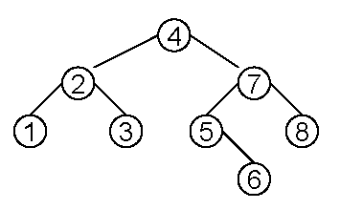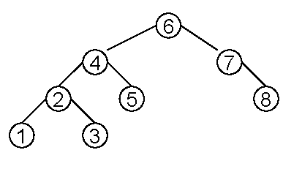
After search(6)

- (2 points) Show the set structure that results after WeightedUnion(a, e) (using weight/length as the heuristic) is called on the following linked-list implementation of disjoint sets.
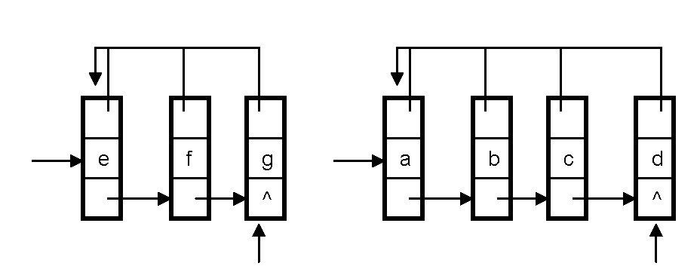

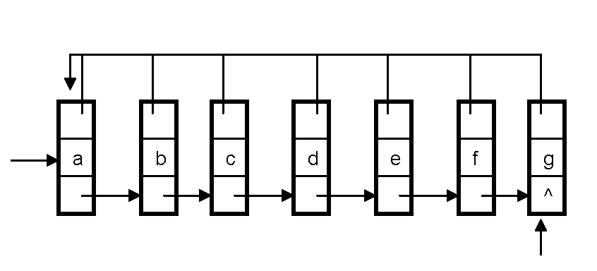

(after union())

- (2 points) Show the set structure that results after findSet(6) with path compression is called on the following disjoint-forest implementation of disjoint sets.
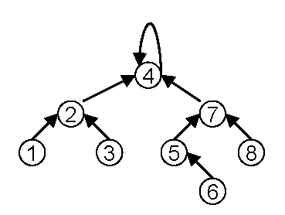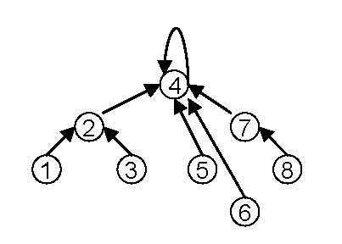
After findSet(6)

